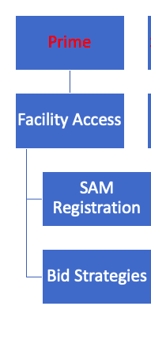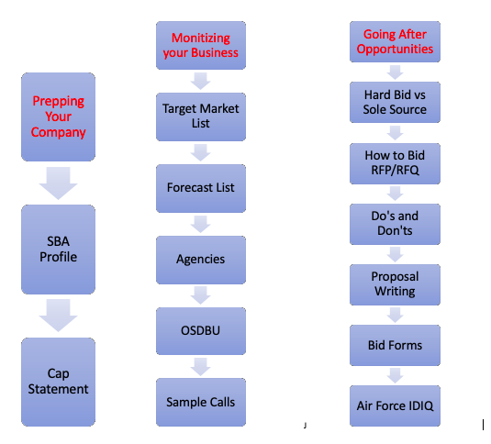

Facility Access
Facility Access
- Access any federal facility
- Lesson: How to meet someone on a military installation
- Homework

System for Award Management (SAM)
System for Award Management (SAM)
- Login.gov
- Lesson: SAM

Bid Strategies

Working with Prime Contractors
- Finding Federal Contracting Opportunities During & After COVID-19 - Eric Coffie (draft)
- Recent Award Winners
- Lesson: How to find the award winners
- HW: Make a list of 10 companies
- Becoming a subcontractor

Preparing your company
- Are you ready to win a contract, prepare your corporation for success using IDV #BetaSamGov

Simplified Acquisition Procedures
- What is an RFI-Sources sought, the rule of two and why does it matter_ #ericcoffieproposal
- Demystifying Simplified Acquisitions Procedures SAP contracts

Prepping your company

SAM 2.0 Completing Your SBA Profile Build a winning SAM Profile

Build a winning SAM Profile

Why your SBA profile is important

How to build a Winning DSBS profile

Model DSBS profiles of Top firms

SBA Profile (Checklist)

Test your knowledge - Quiz
Capability Statement

Crafting a million dollar Cap Statement
- Cap statement Intro
- Building an award winning Capability statement
- Find templates to model in today's HW
- Capability Statement (Checklist)
- Test your knowledge – Quiz

Monetizing your Business

Target Market List: Who buys your services?

Building a Customer Database MasterClass (Target Market List)

Step 1 - Learning the Basics of Search

Step 2 - How to read the Data

Step 3 - What information should I be gathering

Step 4 - Finalizing your database

Step 5 - Finding OSDBU using Contract Office Names

Target Market List (TML) Checklist

Pivot Tables 101

Pivot Tables 102

Find out how much 8a, HUBZone, WOSB spending in your state

Using USA Spending for Research

USA Spending Part 1
USA Spending Part

Forecast List

Forecast List

What is a Forecast List?

Lesson: How to find your forecast list?

HW: Prepare for Strategy Day

Test your knowledge – Quiz\

Agencies
AGENCIES
- Meeting the Contract Officer
- Lesson: Who should I be visiting?
- HW: Scheduling your first meeting

OSDBU
OSDBU
- Setting up a meeting with your OSDBU / Small Business Specialist
- Lesson:How to find your local OSDBU
- HW: 4 Reasons to visit your OSDBU
- Action Steps
- FEAR of calling the OSDBU
- Calling CO to get OSDBU phone number
- ACC attempt to get contact info for OSDBU via FBO
- Explanation for calling OSDBU Cheryl Chandler
- OSDBU Email Script
- Army National Guard call
- NAVFAC 2018 Small Business Specialist POC

Sample Calls

Sample Calls

Calling OSDBU Cheryl Chandler

ACC phone call preparation

FBO email script to get OSDBU information

Rose Stokes Smalls

NOAA Jeff Hale

Army National Guard calls

Tony Micc mistake email mixup

Calling Army Contracting Command

Email response MVI 1858

Going After Opportunities

Hard Bid vs Sole Source
HARD BID VS SOLE SOURCE
- Learn about the types of purchases
- How do we move form competitive to non competitive?
- HW: Work towards more negotiated projects
- Test your knowledge

How to Bid RFP / RFQ

HOW TO BID RFP / RFQ
- RFP vs RFQ Intro
- Mo Formula
- How to use DIBBS
- Using beta.sam.gov for the first time
- How read opportunities on beta.sam.gov
- How to leverage beta.sam.gov
- Subcontractor Package
- Subcontractor Agreement (include Flow Down Clauses)
- Agency Issued Tax Exemption Certificate
- City of Virginia IT RFP + Bid Submission
- DOI NPS - Construction RFP + Bid Submission (Technical Volumes) + Award

HARD BID VS SOLE SOURCE
- Learn about the types of purchases
- How do we move form competitive to non competitive?
- HW: Work towards more negotiated projects
- Test your knowledge

TOOLS
- Where to start with my Brand?
- What components do I need in my brand?
- Get started building your brand with today's HW
- Test your knowledge

CERTIFICATIONS
- Small Business Mastery Webinar
- VA Entrepreneurship Program
- Small Business Mastery Slides
- 8a Checklist
- ED-WOSB Checklist for SBA Certification
- HUBZone Document Checklist

BID FORMS
- SF30 Amend 002
- DLA SF Form 18
- Standard Form 30 Solicitation
- Standard Form 18 Department of Interior
- Bid Worksheet
- Cost Estimate Ft Belvoir example

Do's and Don'ts
Do's and Don'ts
- Things to beware of when bidding

Proposal Writing

Air Force Base IDIQ 5yr MACC: Complete RFP + Bid Submission

Bid Documents

Technical Volumes I

Technical Volume II & III

Debrief Evaluation

PROPOSAL WRITING

Solicitation Structure

Two Important Things

Sample IDIQ Technical Proposal

Construction QC Plan Sample

Hazard Waste Management Program FINAL

Shoring Plan Example

Technical Approach sample

Cotton Mills - Complete Set of Bid Documents + RFP Solicitation

Solicitation – RFP

Volume I & II

Award Notice

Proposal Writing

Traditional Approach

Untraditional Approach

YouTube Live

BID FORMS
BID FORMS
- SF30 Amend 002
- DLA SF Form 18
- Standard Form 30 Solicitation
- Standard Form 18 Department of Interior
- Bid Worksheet
- Cost Estimate Ft Belvoir example

Air Force Base IDIQ

Air Force Base IDIQ 5yr MACC: Complete RFP + Bid Submission

Bid Documents

Technical Volumes I

Technical Volume II & III

Debrief Evaluation

Electives

Supplier Credit
How to build massive Supplier Credit
- Learn the rules of vendor credit
- Steps to building supplier $$$ credit
- HW: Apply for your vendor credit now

Joint Partners & Mentors

Finding Partners on DSBS
- Finding Partners
- Lesson: Learn to search database of contract award winners
- Finding an 8a partner
- HW: Start searching today!

JV and Teaming
- YouTube Live

IDV Video

Cost Estimate

Are you ready to win a contract: using IDV
8a BD PROGRAM
8a BD PROGRAM
- How 8a BD Program Works
- How can BOS help me
- What is a an SBA PCR
- Prepare for SBA BOS Meeting
- 8a Program Certification Specialist Interview

